## VIVEKANAND EDUCATION SOCIETY’S INSTITUTE OF TECHNOLOGY

**Department of Computer Engineering**



Project Report on

AI-Driven Table Tennis Scoring and Ball Speed Tracking

In partial fulfilment of the Fourth Year, Bachelor of Engineering (B.E.) Degree in Computer Engineering at the University of Mumbai

Academic Year 2024-25

### Submitted by

Ajay Gangwani - D17A - 15

Priyanshu Gurwani - D17A - 21

Uday Harisinghani - D17A - 22

Sonnal Katara - D17C - 32

### Project Mentor

Prof. Vidya Zope

(2024-25)

## VIVEKANAND EDUCATION SOCIETY’S INSTITUTE OF TECHNOLOGY

**Department of Computer Engineering**



**Certificate**

This is to certify that **Ajay Gangwani(D17A, 15), Priyanshu Gurwani (D17A, 21), Uday Harisinghani (D17A,22), Sonnal Katara(D17C, 32*)*** of Fourth Year Computer Engineering studying under the University of Mumbai have satisfactorily completed the project on “**AI-Driven Table Tennis Scoring and Ball Speed Tracking** ” as a part of their coursework of PROJECT-II for Semester-VIII under the guidance of their mentor **Prof. Vidya Zope** in the year 2024-25 .

This project report entitled **AI-Driven Table Tennis Scoring and Ball Speed Tracking** by  ***Ajay Gangwani, Priyanshu Gurwani, Uday Harisinghani ,Sonnal Katara***is approved for the degree of **B.E. Computer Engineering.**

| Programme Outcomes | Grade |
| --- | --- |
| PO1,PO2,PO3,PO4,PO5,PO6,PO7, PO8, PO9, PO10, PO11, PO12 PSO1, PSO2 |  |

Date:

Project Guide:



**Project Report Approval**

**For**

**B. E (Computer Engineering)**

This project report entitled **AI-Driven Table Tennis Scoring and Ball Speed Tracking** by ***Ajay Gangwani, Priyanshu Gurwani, Uday Harisinghani, Sonnal Katara*** is approved for the degree of **B.E. Computer Engineering.**

Internal Examiner



External Examiner



Head of the Department



Principal



Date:

Place: Mumbai

**Declaration**

We declare that this written submission represents our ideas in our own words and where others' ideas or words have been included, we have adequately cited and referenced the original sources. We also declare that we have adhered to all principles of academic honesty and integrity and have not misrepresented or fabricated or falsified any idea/data/fact/source in our submission. We understand that any violation of the above will be cause for disciplinary action by the Institute and can also evoke penal action from the sources which have thus not been properly cited or from whom proper permission has not been taken when needed.



Ajay Gangwani(15) Priyanshu Gurwani(21)



Uday Harisinghani(22) Sonnal Katara(32)

Date:

# ACKNOWLEDGEMENT

We are thankful to our college Vivekanand Education Society’s Institute of Technology for considering our project and extending help at all stages needed during our work of collecting information regarding the project.

It gives us immense pleasure to express our deep and sincere gratitude to Assistant Professor **Prof. Vidya Zope** (Project Guide) for her kind help and valuable advice during the development of project synopsis and for her guidance and suggestions.

We are deeply indebted to Head of the Computer Department **Dr. (Mrs.) Nupur Giri** and our Principal **Dr. (Mrs.) J. M. Nair ,** for giving us this valuable opportunity to do this project.

We express our hearty thanks to them for their assistance without which it would have been difficult in finishing this project synopsis and project review successfully.

We convey our deep sense of gratitude to all teaching and non-teaching staff for their constant encouragement, support and selfless help throughout the project work. It is a great pleasure to acknowledge the help and suggestion, which we received from the Department of Computer Engineering.

We wish to express our profound thanks to all those who helped us in gathering information about the project. Our families too have provided moral support and encouragement several times.

### Computer Engineering Department COURSE OUTCOMES FOR B.E PROJECT

Learners will be to,

| **Course Outcome** | **Description of the Course Outcome** |
| --- | --- |
| CO 1 | Able to apply the relevant engineering concepts, knowledge and skills towards the project. |
| CO2 | Able to identify, formulate and interpret the various relevant research papers and to determine the problem. |
| CO 3 | Able to apply the engineering concepts towards designing solutions for the problem. |
| CO 4 | Able to interpret the data and datasets to be utilised. |
| CO 5 | Able to create, select and apply appropriate technologies, techniques, resources and tools for the project. |
| CO 6 | Able to apply ethical, professional policies and principles towards societal, environmental, safety and cultural benefit. |
| CO 7 | Able to function effectively as an individual, and as a member of a team, allocating roles with clear lines of responsibility and accountability. |
| CO 8 | Able to write effective reports, design documents and make effective presentations. |
| CO 9 | Able to apply engineering and management principles to the project as a team member. |
| CO 10 | Able to apply the project domain knowledge to sharpen one’s competency. |
| CO 11 | Able to develop a professional, presentational, balanced and structured approach towards project development. |
| CO 12 | Able to adopt skills, languages, environment and platforms for creating innovative solutions for the project. |

# Index

| Chapter No. | Title | Page No. |
| --- | --- | --- |
| **1** | **Introduction** | 12 |
| 1.1 | Introduction to the project | 12 |
| 1.2 | Motivation for the project | 12 |
| 1.3 | Problem Definition | 12 |
| 1.4 | Existing Systems | 13 |
| 1.5 | Lacuna of the Existing Systems | 13 |
| 1.6 | Relevance of the Project | 14 |
| **2** | **Literature Survey** | 15 |
| A | Brief overview of Literature Survey | 15 |
| 2.1 | Research Papers   1. Abstract of the research paper 2. Inference drawn from the paper | 15 |
| 2.2 | Patent search   1. Title of the patent and year of the patent 2. Summary of the patent 3. Link 1. European Patent: [http://worldwide.espacenet.com/,](http://worldwide.espacenet.com/) Link 2. Google Patents: https://patents.google.com/ | 17 |
| 2.3 | Inference Drawn | 18 |
| 2.4 | Comparison with the Existing Systems | 18 |
| **3.** | **Requirement Gathering for the proposed System** | 19 |
| 3.1 | Introduction to Requirement Gathering | 19 |
| 3.2 | Functional Requirements | 20 |
| 3.3 | Non-Functional Requirements | 20 |
| 3.4 | Hardware, Software, Technology and tools utilised | 20 |
| 3.5 | Constraints | 21 |
| **4.** | **Proposed Design** | 22 |
| 4.1 | Block diagram of the system | 22 |
| 4.2 | Modular design of the system | 23 |

| 4.3 | Detailed Design (Flowchart) | 25 |
| --- | --- | --- |
| 4.4 | Project Scheduling & Tracking using Timeline / Gantt Chart | 26 |
| **5.** | **Implementation of the Proposed System** | 27 |
| 5.1 | Methodology employed for development | 27 |
| 5.2 | Algorithms and flowcharts for the respective modules developed | 28 |
| 5.3 | Datasets source and utilisation | 29 |
| **6.** | **Testing of the Proposed System** | 30 |
| 6.1 | Introduction to testing | 30 |
| 6.2 | Types of tests Considered | 30 |
| 6.3 | Various test case scenarios considered | 31 |
| 6.4 | Inference drawn from the test cases | 33 |
| **7.** | **Results and Discussions** | 35 |
| 7.1 | Screenshots of User Interface (UI) for the respective module | 35 |
| 7.2 | Performance Evaluation measures | 37 |
| 7.3 | Input Parameters / Features considered | 38 |
| 7.4 | Comparison of results with existing systems | 39 |
| 7.5 | Inference drawn | 39 |
| **8.** | **Conclusion** | 40 |
| 8.1 | Limitations | 40 |
| 8.2 | Conclusion | 40 |
| 8.3 | Future Scope | 40 |
|  | **References** | 42 |
| a | Project review sheet | 43 |

**List of Figures:**

| Fig no. | Heading | Page no. |
| --- | --- | --- |
| 4.1 | Block Diagram | 22 |
| 4.2.1 | Modular Diagram | 23 |
| 4.2.2 | Object Detection Module | 23 |
| 4.2.3 | Analysis & Scoring Module | 24 |
| 4.2.4 | Output Module | 24 |
| 4.3.1 | DFD | 25 |
| 4.3.2 | Flowchart of model | 25 |
| 4.4 | Gantt Chart | 26 |
| 5.2.1 | Detection Flowchart | 28 |
| 5.2.2 | Tracking Flowchart | 28 |
| 5.2.3 | Scoring Flowchart | 29 |
| 7.1 | Player Detection | 35 |
| 7.2 | Scoring System | 35 |
| 7.3 | Table and Net Detection | 36 |
| 7.4 | Output of System | 36 |

**List of Tables:**

| Table no. | Heading | Page no. |
| --- | --- | --- |
| 2.4 | Comparison with existing systems | 18 |
| 3.1 | Requirements of the system | 19 |
| 6.3 | Test Cases | 32 |
| 6.4 | Inference from Test Cases | 34 |

# Abstract

The advancement of artificial intelligence and computer vision has enabled automation in various domains, including sports analytics. This project aims to develop an advanced table tennis detection and scoring system using computer vision techniques with OpenCV. The system is designed to track the table tennis ball in real-time, calculate its speed, and update the scores for both players. It employs template matching for table and net detection, edge and corner detection for line identification, and background subtraction for ball tracking. These techniques enable precise ball path analysis and bounce detection, creating a comprehensive and efficient sports analysis tool that integrates multiple computer vision algorithms.

The system is developed using OpenCV, Python, and deep learning frameworks, ensuring efficient processing and real-time performance. A user-friendly graphical interface allows players, coaches, and referees to interact with the system seamlessly. This project aims to revolutionize table tennis training and officiating by providing an automated, reliable, and intelligent sports analytics tool.

# Chapter 1: Introduction

## Introduction:

Table tennis is a sport that requires precision, speed, and reflexes. Given the rapid movement of the ball, accurate tracking of its motion and scoring is vital for both professional and recreational players. Traditional scoring and ball tracking methods rely heavily on human judgment, which can be prone to errors, especially in fast-paced scenarios. This project focuses on the development of an AI-driven system for table tennis scoring and ball speed tracking using advanced computer vision techniques. By integrating OpenCV with template matching, edge detection, and background subtraction, the system will automate real-time ball tracking, calculate speed, and accurately update scores.

## Motivation:

With the growing influence of artificial intelligence and computer vision in sports analytics, automating processes like scoring and ball tracking in table tennis presents an exciting challenge. Manual methods are often subjective and error-prone, and the lack of real-time feedback can diminish the player experience. This project aims to bridge this gap by leveraging the power of AI to deliver more accurate and reliable outcomes in table tennis matches. The motivation stems from the need to reduce human error, enhance accuracy, and promote the application of AI in sports.

## Problem Definition:

The primary challenge in developing an advanced table tennis detection and scoring system lies in the complexities of accurately detecting and tracking a small, fast-moving ball in real-time. Table tennis balls can reach speeds exceeding 31m/s, making manual tracking difficult and error-prone. Additionally, the small size of the ball and its rapid movement pose significant challenges for computer vision systems, which must distinguish the ball from various backgrounds and track its trajectory accurately. The system must be able to differentiate between ball bounces on the table and other interactions, such as collisions with the net or paddle, and false positives from background noise. This requires robust detection algorithms that can maintain high accuracy even under varying lighting conditions and different camera angles.

Moreover, the system must correctly identify the table boundaries, net position, and player areas to ensure accurate scoring. Misidentification of these elements can lead to incorrect scoring, which undermines the reliability and usefulness of the system. Real-time processing is crucial, as delays in detection and scoring can disrupt the flow of the game and degrade the user experience. The system must also be resistant to obstacles, where the ball might be temporarily obscured by players or equipment, and be capable of recovering quickly to continue accurate tracking. These combined challenges necessitate a sophisticated integration of multiple computer vision techniques to create a comprehensive and efficient solution that can operate reliably in a dynamic and fast-paced environment.

The primary challenges in developing a table tennis detection and scoring system include:

* Accurately detecting and tracking a small, fast-moving ball.
* Differentiating between ball bounces on the table and other interactions.
* Correctly identifying table boundaries, net position, and player areas.
* Real-time processing to ensure immediate scoring updates.

This project mostly focuses on providing skills which are required for the particular job. Using these skills they can apply for the jobs on the same portal where they will be directly contacted by the organizations. Also if anyone wants to start their own venture can do so by applying for the crowdfunding which will be verified by the admins. Furthermore, this system enhances the understanding concept and importance of the job portal for students.

## Existing Systems:

Currently, there are no dedicated AI-driven systems specifically designed for table tennis scoring and ball speed tracking. While technologies such as Hawk-Eye in tennis and SwingVision in table tennis and other sports provide advanced ball tracking and analytics, these solutions either focus on different sports or offer limited functionality that doesn't fully align with the objectives of this project.

Most existing systems in table tennis rely on manual methods for scoring and lack real-time, automated speed tracking or bounce detection. The current solutions either use basic video analysis for training purposes or are limited to rudimentary tracking, without integrating advanced AI and computer vision techniques for comprehensive game analysis.

This absence of a fully automated AI-based system for real-time scoring and ball speed tracking in table tennis highlights the need and relevance of this project.

## Lacuna of the Existing System:

* + 1. **Accuracy in Varied Conditions:** The system may face difficulties in maintaining consistent accuracy during ball detection and tracking under different lighting conditions or varying backgrounds. Proper calibration might be required to handle these changes effectively.
    2. **Limited Generalization Across Sports**: While the system is designed for table tennis, it may not perform optimally for other sports like badminton or squash, which have different ball dynamics and court dimensions, thus requiring sport-specific tuning.
    3. **High-Speed Ball Detection**: Detecting and accurately tracking fast-moving balls in table tennis, which can reach speeds of up to 31m/s, could pose a challenge, potentially leading to miscalculations in speed and trajectory.
    4. **Obstacles and Occlusion**: The presence of players or equipment can block the camera's view, temporarily halting ball detection and leading to inaccurate tracking, especially in fast-paced matches.
    5. **Net and Boundary Violations**: The system might struggle with detecting boundary and net violations accurately during high-speed rallies, especially when the ball barely grazes the net or lands near the edge of the table.

## Relevance of the Project:

In the highly competitive world of sports, data plays an increasingly crucial role in decision-making and performance enhancement. Accurate, real-time data allows athletes, coaches, and analysts to make informed judgments about game strategies, player performance, and areas for improvement. This project, focused on table tennis, contributes to the evolving field of sports analytics by automating the process of ball tracking, speed calculation, and scoring. Traditionally, scoring in table tennis has been manual, requiring human intervention, which is prone to error, especially in fast-paced games. By integrating artificial intelligence (AI) and computer vision techniques, this project removes the element of human error and provides a more precise, objective, and consistent scoring system. This leads to a more transparent and fair competition environment, where both players and spectators can rely on the data being recorded accurately.

Beyond its implications for live matches, this project offers substantial benefits in training environments. Automated ball tracking and performance data allow athletes to monitor their playing habits, such as the speed of their shots, ball placement, and reaction times, with unparalleled precision. This real-time feedback can enhance coaching strategies, as coaches can tailor training regimens based on detailed, data-driven insights rather than just observation. Additionally, the system allows players to analyze specific movements and refine their techniques, ultimately improving their skills more effectively. The combination of automated tracking and real-time analytics provides players and teams with a competitive edge, making this project highly relevant in the modern landscape of sports technology and analytics.

# Chapter 2: Literature Survey

## A. Overview of literature survey:

The papers discussed here focus on various job recommendation skills as well as different skills and job portals. These papers are studied to understand how the skills and jobs are dependent on each other. The studies examine how to create the job recommendation system more efficiently. Overall, the papers highlight the importance of taking a comprehensive approach to address how these above factors can be used and enhanced for the development of a complete system which can provide both the courses as well as jobs.

## Research Papers :

* + 1. **W. Li, X. Tan and Z. Wang, "Small Object Detection of Table Tennis Based on Deep Learning Network," 2020 International Conference on Computer Science and Management Technology (ICCSMT), Shanghai, China**
       1. **Abstract Summary**: This paper addresses the challenge of detecting small, fast-moving objects in real-time, particularly focusing on table tennis. The authors propose a deep learning network optimized for small object detection by balancing detection speed and accuracy. They constructed a dataset of 20,000 table tennis images and utilized a convolutional neural network (CNN) with residual connections. By combining layers with rich semantic information and object position information, the proposed system enhances detection accuracy. A novel data augmentation technique was introduced, significantly improving the model's learning capability for small targets. Experimental results confirmed the model's superior accuracy and speed in table tennis ball detection, making it suitable for real-time applications.
       2. **Inference:** This research is highly relevant to our project as it directly tackles the issue of small object detection in fast-paced environments like table tennis. The use of CNN and residual connections, along with feature pyramids, provides valuable insight into how we can enhance our own ball tracking model. The idea of data augmentation can also be applied to our dataset to improve model accuracy
    2. **H. Myint, P. Wong, L. Dooley and A. Hopgood, "Tracking a table tennis ball for umpiring purposes," 2015 14th IAPR International Conference on Machine Vision Applications (MVA), Tokyo, Japan, 2015**
       1. **Abstract:** This study investigates tracking a table-tennis ball rapidly from video captured using low-cost equipment for umpiring purposes. A number of highly efficient algorithms have been developed for this purpose. The proposed system was tested using sequences capture from real match scenes. The preliminary results of experiments show that accurate and rapid tracking can be achieved even under challenging conditions, including occlusion and colour merging. This work can contribute to the development of an automatic umpiring system and also has the potential to provide amateur users with open access to a detection tool for fast-moving, small, round objects.
       2. **Inference:** This study demonstrates that accurate and rapid tracking of a table tennis ball can be achieved using low-cost video equipment, making it suitable for automated umpiring. The system's ability to handle occlusion and color merging under real match conditions shows its effectiveness. These results suggest that the system can contribute to automatic umpiring and provide open-access tools for amateur players to track fast-moving, small objects. This work opens doors for affordable, AI-driven sports analytics in both professional and recreational settings.
    3. **R. Voeikov, N. Falaleev and R. Baikulov, "TTNet: Real-time temporal and spatial video analysis of table tennis," 2020 IEEE/CVF Conference on Computer Vision and Pattern Recognition Workshops (CVPRW), Seattle, WA, USA, 2020**
       1. **Abstract:** It presents a neural network TTNet aimed at real-time processing of high-resolution table tennis videos, providing both temporal (events spotting) and spatial (ball detection and semantic segmentation) data. This approach gives core information for reasoning score updates by an auto-referee system. We also publish a multi-task dataset OpenTTGames with videos of table tennis games in 120 fps labeled with events, semantic segmentation masks, and ball coordinates for evaluation of multi-task approaches, primarily oriented on spotting of quick events and small objects tracking. TTNet demonstrated 97.0% accuracy in game events spotting along with 2 pixels RMSE in ball detection with 97.5% accuracy on the test part of the presented dataset.The proposed network allows the processing of downscaled full HD videos with inference time below 6 ms per input tensor on a machine with a single consumer-grade GPU. Thus, we are contributing to the development of real-time multi-task deep learning applications and presenting an approach, which is potentially capable of substituting manual data collection by sports scouts, providing support for referees' decision-making, and gathering extra information about the game process.
       2. **Inference:** The study presents TTNet, a neural network for real-time processing of high-resolution table tennis videos, offering both temporal event spotting and spatial ball detection. With 97.0% accuracy in event spotting and 2 pixels RMSE in ball detection, TTNet shows promising potential for automated score updates and referee support. The OpenTTGames dataset, containing labeled high-frame-rate videos, is introduced for evaluating multi-task approaches in quick event spotting and small object tracking. TTNet’s ability to process full HD videos with low inference time on consumer-grade hardware suggests its potential to replace manual data collection and assist referees in real-time decision-making.

## Patent Search :

* + 1. **BALL TRACKING SYSTEM AND METHODS (US6320173B1)**

**Inventors**: Curtis A. VockKevin J. GrealishRobert D. FreyDennis DarcyJoseph Bianco.

The invention monitors the driving range and tracks golf balls from users at the driving range and informs those users of characteristics such as driving distance. A solid state camera images the range, and preferably one or more tee-off positions, and collects frames of image data to track a ball's motion through space. Simulation routines augment that track and assist in isolating the start location as well as where the ball lands, or would have landed had it not been obstructed (e.g., by a net). Preferably, the invention also determines the ball's position in 3-D to increase the accuracy. In one technique, two or more solid state cameras are used, and synchronized, to specify stereoscopic imaging. In another technique, the ball's energy or physical extent is used to determine an absolute distance between the camera and the ball. A computer at the club house monitors the entire system and further manages a network including an array of displays at the several tee off positions. The computer thus sends information such as distance to the several users via the network.

* + 1. **AUTOMATED SCORING SYSTEM FOR TABLE TENNIS (US9959525B2)**

**Inventors**: Safari Chung

Described are systems and methods for automatically scoring a table tennis game. In particular, a system for automatically scoring a table tennis game may include a sensor, a microcontroller, a display, a speaker, a table tennis net support, and/or a power supply. Methods for automatically scoring a table tennis game comprise indicating that a serve may proceed; detecting a vibration or absence of a vibration formed by contact between a table tennis ball with a table tennis table and/or between a table tennis ball and a table tennis net; determining which player served; determining if a point should be awarded based on detecting a vibration or absence of vibration; modifying the score of a table tennis game; displaying the score of a table tennis game; determining if a sensor is operational; and/or playing a sound effect.

## Inference Drawn:

* In all the patents and existing systems we have reviewed, very few offer a **complete solution that combines real-time ball tracking, scoring automation, and match analytics** using computer vision alone. Most systems rely on **hardware sensors or external devices**, making them expensive or complex for widespread use.
* We drew inspiration from the system proposed by **Safari Chung** (US9959525B2) but aimed to design a **more accessible, software-driven solution** using **OpenCV and machine learning** techniques for ball detection, scoring, and performance analysis. Our approach focuses on affordability, ease of deployment, and application for both **professional and amateur** level matches.

## Comparison with the Existing Systems:

| **Other System** | **Our System** |
| --- | --- |
| Primarily rely on external hardware like sensors or vibration detectors | Uses computer vision and machine learning for a software-based, cost-effective solution |
| Focus only on scoring or only on ball tracking | Combines ball tracking, bounce detection, and automated scoring in one integrated system |
| Often designed for high-end professional use | Designed to be accessible and usable even by amateurs and training institutes |
| Struggle with visual challenges like occlusion or background noise | Employs background subtraction, edge detection, and template matching to improve tracking accuracy |

# 

**Table No 2.4: Comparison with existing systems**

# Chapter 3: Requirement Gathering for the Proposed System

In this chapter we are going to discuss the resources we have used and how we analysed what the user actually needs and what we can provide. We will also discuss the functional and non-functional requirements and finally the software and hardware used.

## Introduction to Requirement Gathering:

The Requirement Gathering is a process of requirements discovery or generating list of requirements or collecting as many requirements as possible by end users. It is also called as requirements elicitation or requirement capture.

The requirements gathering process consists of six steps :

* + - Identify the relevant stakeholders
    - Establish project goals and objectives
    - Elicit requirements from stakeholders
    - Document the requirements
    - Confirm the requirements
    - Prioritise the requirements

| USE CASE | DESCRIPTION |
| --- | --- |
| Ball Detection | The system uses machine learning algorithms for accurate ball tracking and detection, performing well under typical conditions, but may face limitations with extremely fast ball speeds and intense scenarios. |
| Ball Tracking | The system will automatically track the ball’s movement in real-time using **OpenCV** and **AI algorithms**. |
| Real-Time Score Update | The system will automatically calculate scores based on detected bounces, shots, and events. |
| Bounce Detection | The system will identify bounces to determine valid points and score updates. |
| Match Analysis | Detailed match analysis, including ball speed, bounce location will be provided. |

**Table No 3.1: Requirements of the system**

## Functional Requirements:

* + - Real-time detection and tracking of the ball during a match.
    - Automatic scoring based on ball bounces, player interaction, and game rules.
    - Speed calculation of the ball and trajectory analysis.
    - Detection of invalid bounces (e.g., hitting the net) and scoring adjustments.

## Non-Functional Requirements:

* + - Accuracy: The system must accurately detect the ball’s location, speed, and trajectory within the given time constraints.
    - Performance: The system should handle video processing in real-time, maintaining minimal lag for optimal player and viewer experience.
    - Scalability: The system should adapt to different environments such as practice sessions or competitive matches.
    - Reliability: The system should maintain consistent performance even under challenging conditions like lighting changes or camera occlusion.

## Hardware, Software, Technology and Tools Utilised:

### Hardware Requirements:-

* 1. High-speed camera for real-time video capture.
  2. Computer with sufficient processing power

### Software Requirements:-

* 1. OpenCV library for computer vision tasks.
  2. Python as the programming language.
  3. Integrated Development Environment (IDE)

### Techniques:-

* **OpenCV:** This library is crucial for video analysis, template matching, and image processing.
* **NumPy:** For numerical computations involved in speed calculations and other mathematical functions.
* Python: The primary language used for developing the software modules.  
   IDE: For code development and debugging.

### Tools:-

* **Vscode:-**Visual Studio Code is a streamlined code editor with support for development operations like debugging, task running, and version control. It aims to provide just the tools a developer needs for a quick code-build-debug cycle and leaves more complex workflows to fuller featured IDEs, such as Visual Studio IDE.

## Constraints:

* + - **Processing Speed:** Real-time video processing demands high computational power. Delays in processing could result in inaccurate scoring or ball tracking lags.
    - **Ball Color and Design:** Variations in the color or markings on the ball (e.g., logos or patterns) might affect the system's ability to consistently detect and track it, especially if it blends with the background.
    - **Occlusion by Players:** Players’ movements may occasionally block the camera's view of the ball, causing temporary tracking failure.
    - **Varying Camera Angles:** Changes in the camera angle or positioning can affect the accuracy of the system’s algorithms, requiring recalibration or adjustment.
    - **Ball Speed Variability:** The system must accurately track balls at both high and low speeds. Rapid changes in speed during play could challenge the system's ability to maintain continuous detection.

# Chapter 4: Proposed Design

## Block Diagram of the proposed system:

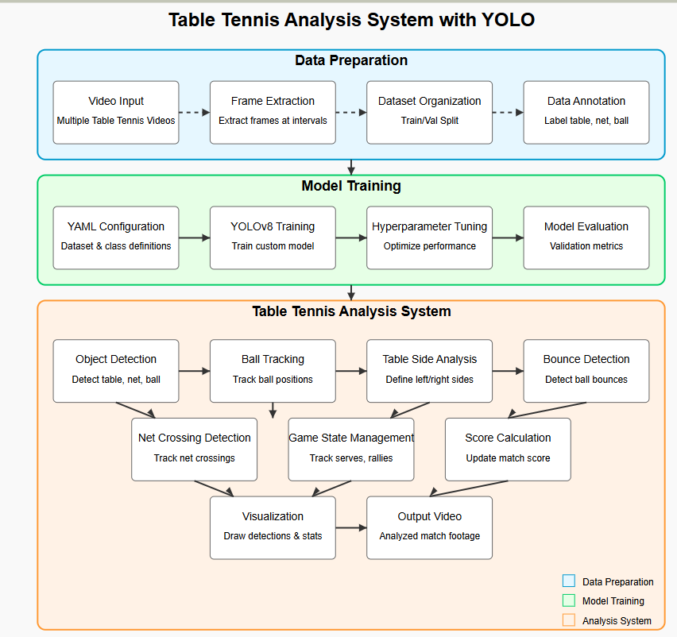

**Fig 4.1: Block Diagram**

## Modular diagram of the system:

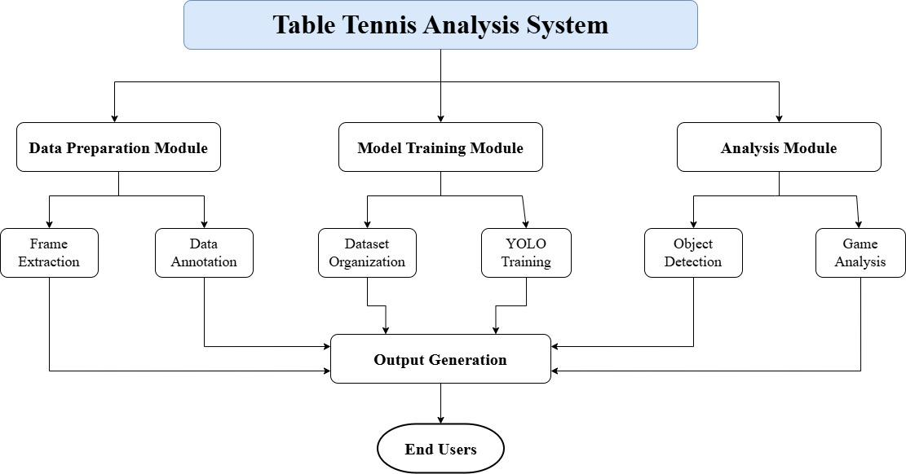

**Fig 4.2.1: Modular Diagram**

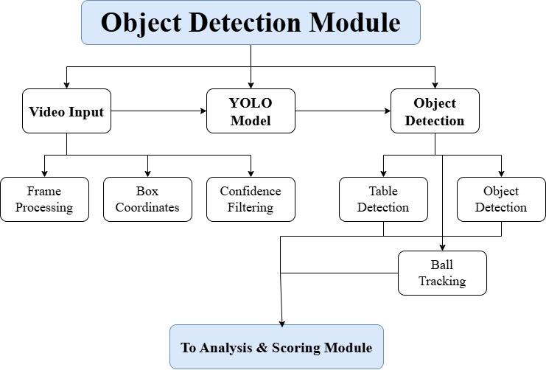

**Fig 4.2.2: Object Detection Module**

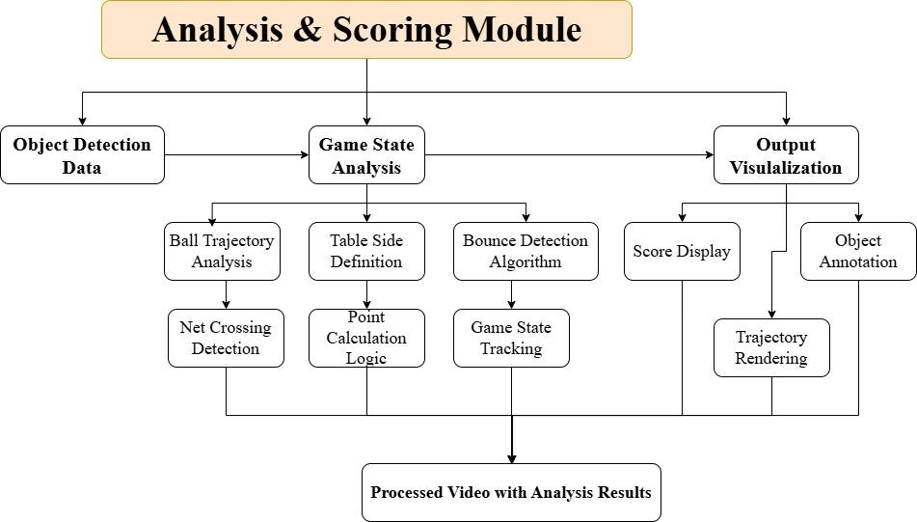

**Fig 4.2.3: Analysis & Scoring Module**

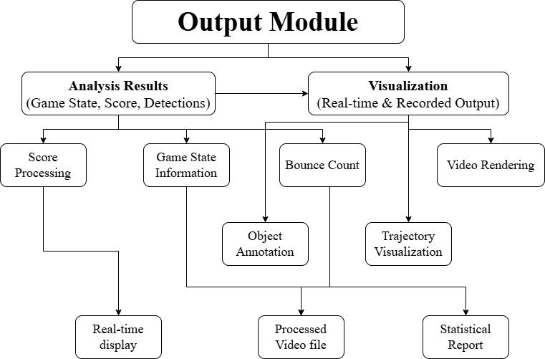

**Fig 4.2.4: Output Module**

## Detailed Design

### DFD Level 0:

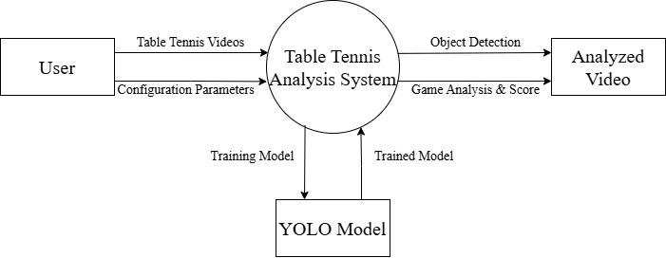

**Fig 4.3.1: DFD**

### Flowchart for the proposed system :

The following flowchart shows us the workflow of our project. 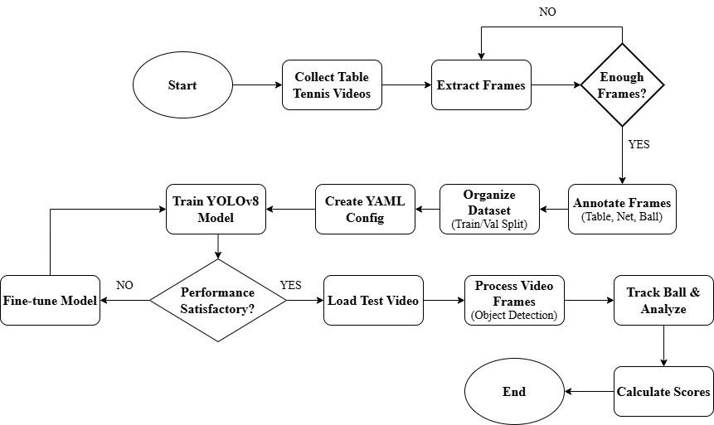

**Fig 4.3.2 : Flowchart of Model**

## Project Scheduling & Tracking using Time line / Gantt Chart:

## The Gantt chart of our project where we worked for the whole semester to create this model is shown in a timeline pattern. It is the most important part to think and design the planning of your topic and so we planned our work like the gantt chart shown.

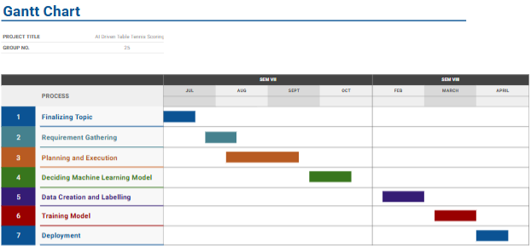

**Fig 4.4 : Gantt chart**

# Chapter 5: Implementation of the Proposed System

## Methodology employed for development:

The AI-Driven Table Tennis Scoring System is designed to automatically detect and score points in real-time using computer vision and deep learning techniques. The methodology involves integrating multiple modules including ball detection, motion tracking, point calculation, and score updating in a synchronized pipeline.

The development process follows the following steps:

1. **Problem Definition & Use Case Analysis**The need for automation in table tennis scoring is identified, particularly in informal or training setups where human referees are not available.
2. **Data Collection and Annotation**Video footage of table tennis matches is collected, and frames are annotated manually to identify the location of the ball for training a detection model.
3. **Model Selection**YOLOv8 (You Only Look Once – version 8), a real-time object detection model, is chosen due to its accuracy and speed in detecting small and fast-moving objects like a table tennis ball.
4. **Training & Evaluation**The YOLOv8 model is trained on the annotated dataset. Evaluation is done using precision, recall, and mean Average Precision (mAP) metrics to fine-tune model performance.
5. **Tracking and Scoring Logic Implementation**Ball coordinates are used to calculate trajectories. Based on bounce counts, positions, and net interactions, the system decides if a point is scored and by whom.
6. **User Interface Integration**A scoreboard interface is integrated with the backend logic so that it updates automatically based on real-time video analysis.

This modular approach ensures that each component—detection, tracking, scoring, and UI—is developed, tested, and optimized independently before integration.

## Algorithms and Flowcharts for the respective modules developed:

Several key algorithms have been implemented to achieve reliable scoring from video data:

**1. YOLOv8 Object Detection Algorithm (Ball Detection)**

* This algorithm processes each video frame to detect the location of the table tennis ball using bounding boxes.
* It uses convolutional layers to extract spatial features and predict object locations in real time.

**2. Kalman Filter or Centroid Tracking Algorithm (Ball Tracking)**

* After detection, a tracking algorithm is used to maintain consistent tracking of the ball between frames.
* Kalman filters or centroid tracking methods predict the next likely position of the ball, reducing jitter and improving continuity.

**3. Scoring Algorithm**

* Tracks the ball’s interaction with the table and net.
* Determines if the ball bounced on the opponent’s side or went out of bounds.
* A point is awarded based on violations like missed returns or out-of-bound shots.

**4. Rule-Based Decision System**

* Implements table tennis rules (e.g., ball bounce must occur once, net faults, side change after every 2 points).
* Triggers scoreboard updates based on these decisions.

#### Flowchart Descriptions:

* **Detection Flowchart:**

**Fig 5.2.1 : Detection Flowchart**

* **Tracking Flowchart:**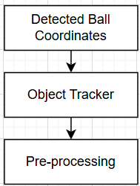

**Fig 5.2.2 : Tracking Flowchart**

* **Scoring Flowchart:**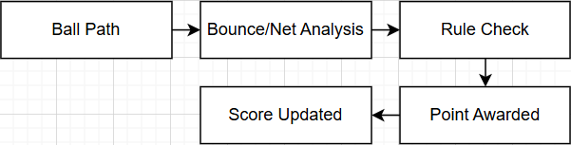

**Fig 5.2.3 : Scoring Flowchart**

## Datasets source and utilisation:

Two major sources of datasets have been used:

**1. Custom Dataset from Video Footage**

* Videos of table tennis matches were collected from sources like YouTube and recorded gameplay.
* These videos were split into frames and annotated manually using tools like LabelImg to mark the ball position.
* The dataset was then formatted in YOLO format and used to train the YOLOv8 model.

**2. Supplementary Synthetic Data**

* To improve robustness, synthetic images were generated where the ball position and lighting conditions were varied artificially.
* This helps improve generalization under different conditions like shadow, blur, and occlusion.

Dataset Attributes and Utilization:

* **Labels**: Ball coordinates (bounding boxes)
* **Image Formats**: JPEG/PNG frames
* **Size**: ~ annotated frames
* **Training Split**: 70% training, 20% validation, 10% testing
* **Utilization**:
  + YOLOv8 uses the training data to learn features of the ball.
  + Validation set ensures the model generalizes beyond the training data.
  + Test set evaluates final model accuracy and inference speed.

The quality of the dataset and annotations directly affects the performance of the scoring system. Hence, a continuous feedback loop is employed to update the dataset with new samples from failure cases.

# Chapter 6: Testing of the Proposed System

## Introduction to Testing :

The AI-Driven Table Tennis Analyzer project demands a careful and structured testing process to ensure its effectiveness and reliability. By following a systematic testing life cycle, we aim to deliver an intelligent system that meets user expectations and enhances the playing experience. Thorough testing is critical because the success of such a system hinges on accuracy, real-time performance, and user trust.

In sports applications, especially where AI is used to analyze high-speed actions like table tennis, any misjudgment or delay can significantly impact the user experience. Therefore, testing becomes an essential phase to ensure that ball detection, speed tracking, and scoring functionalities work correctly under various conditions. Recognizing this need, testing has been embedded deeply into the development process.

The project testing phase consists of activities focused on validating the system’s core features — from ball tracking precision to scoring accuracy — and ensuring they align with the initial design goals. This phase offers an independent review of the analyzer’s performance, helping stakeholders identify potential risks, limitations, or areas for improvement before final deployment. Ultimately, testing helps ensure the AI-Driven Table Tennis Analyzer meets the original specifications and delivers a seamless, accurate, and dependable experience to players and coaches.

## Types of tests Considered:

### Pre testing phase

During the design and implementation stage of the AI-driven table tennis scoring and ball speed tracking system, a pre-test was conducted to gather feedback and refine the system's features. A questionnaire was developed to assess players’ understanding of the tracking system and their expectations for the app's functionalities, including the ability to track ball speed, score the game, and detect player actions. Ten volunteers, consisting of both casual and competitive players, participated in this phase. They were asked questions about their experience with current table tennis tracking systems and their expectations for an improved system that could offer real-time game scoring and ball tracking. The feedback provided by the volunteers was used to fine-tune the algorithm, improve the user interface, and address potential user concerns. Adjustments were made to ensure that the app could handle various types of video input and provide accurate results for different player movements and ball trajectories.

### Beta-Testing Phase

The application was beta-tested with ten users, following a defined protocol. Each participant was asked to 1) upload a video of a table tennis match (either personal or from a library of sample videos), 2) choose the appropriate settings (player count, game rules, etc.), and 3) start the game tracking, including ball detection, speed measurement, and score calculation. Two trained interviewers (research assistants or project developers) conducted the test and asked each user to evaluate the application’s performance. This included questions about the accuracy of ball speed tracking, the usability of the interface, and the app’s ability to differentiate between player actions and environmental distractions (like background movement or lighting changes).

Immediately following the beta test, face-to-face interviews were conducted with the ten users. The semi-structured interview script included open-ended questions designed to assess the overall user experience, such as:

* How intuitive was the app's interface for setting up a match and tracking the game?
* Did the app correctly detect the ball and players' actions?
* Were the game scores calculated accurately in real-time?
* What suggestions do you have to improve the system's speed and accuracy?

The feedback from these interviews was analyzed according to standard qualitative data methods. Based on this feedback, minor adjustments were made, particularly related to user interface layout (e.g., where the ball speed is displayed in relation to the score), the accuracy of the ball detection algorithm (e.g., refining tracking in different lighting conditions), and improving the response time for video processing.

## Various test case scenarios considered:

|  | Test Cases |
| --- | --- |
| Case 1: The ball should be correctly detected in various lighting conditions and different background environments. |  |
| Case 2:  The system should correctly identify and update the score when the ball touches a side of the table. |  |
| Case 3:  The calculated ball speed should be accurate based on frame-to-frame distance tracking. |  |
| Case 4:  The system should distinguish between two players even if both move simultaneously during gameplay. |  |

**Table 6.3 : Test Cases**

## Inference drawn from the test cases:

|  | Test Cases |
| --- | --- |
| Case 1:  The system processes each video frame to detect the ball successfully under various lighting conditions and background variations, ensuring reliable ball detection without relying on video metadata. |  |
| Case 2 :  The system processes frames to track when the ball touches different sides of the table, allowing it to accurately update the player scores in real-time. |  |

| Case 3:  By analyzing consecutive frames, the system calculates the ball speed accurately based on frame-to-frame distance and time difference, rather than external timing data.. |  |
| --- | --- |

**Table 6.4 : Inference from Test Cases**

# Chapter 7: Results and Discussions

## Screenshots of User Interface(UI) for the respective module:

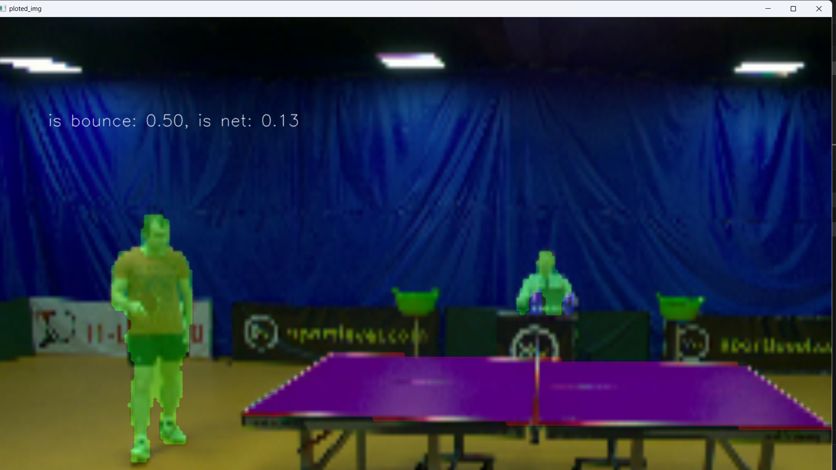

**Fig 7.1 Player Detection**

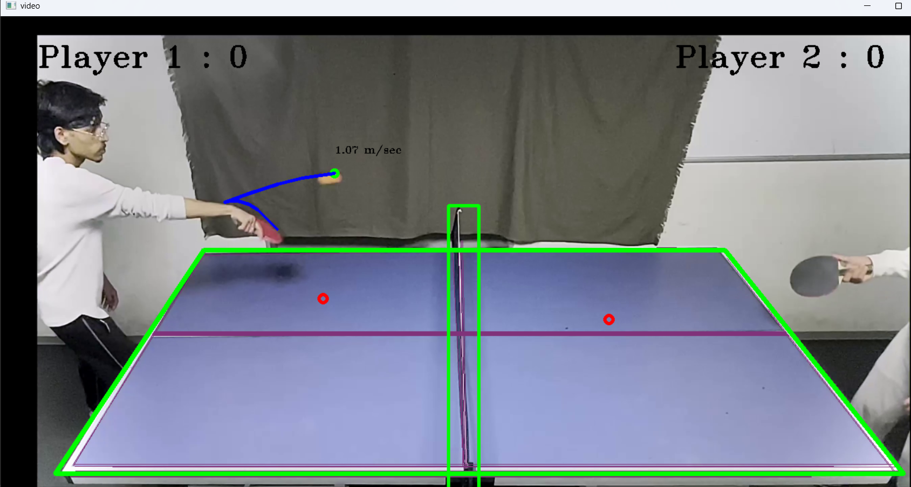

**Fig 7.2 Scoring System**

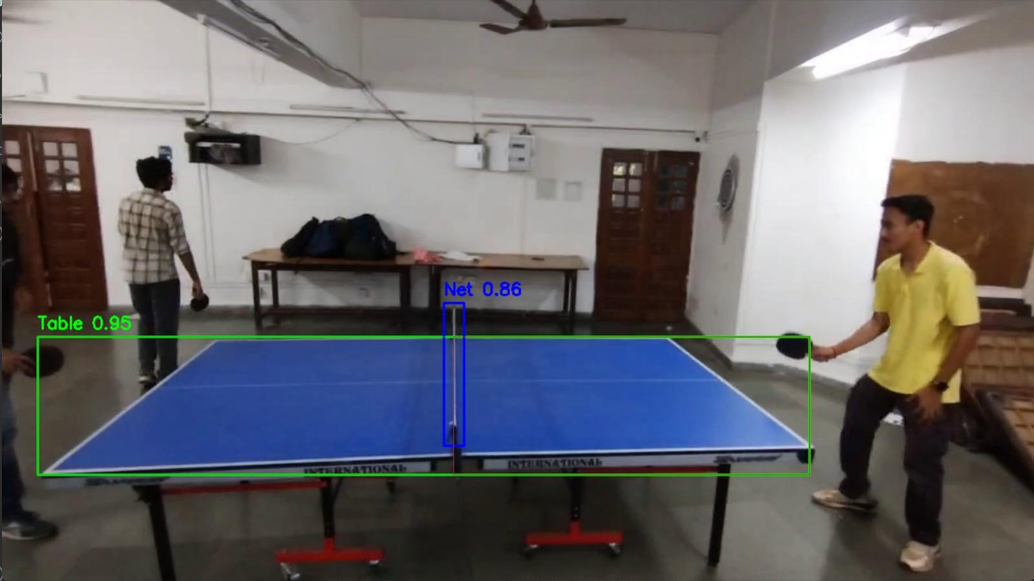

**Fig 7.3: Table and Net detection**

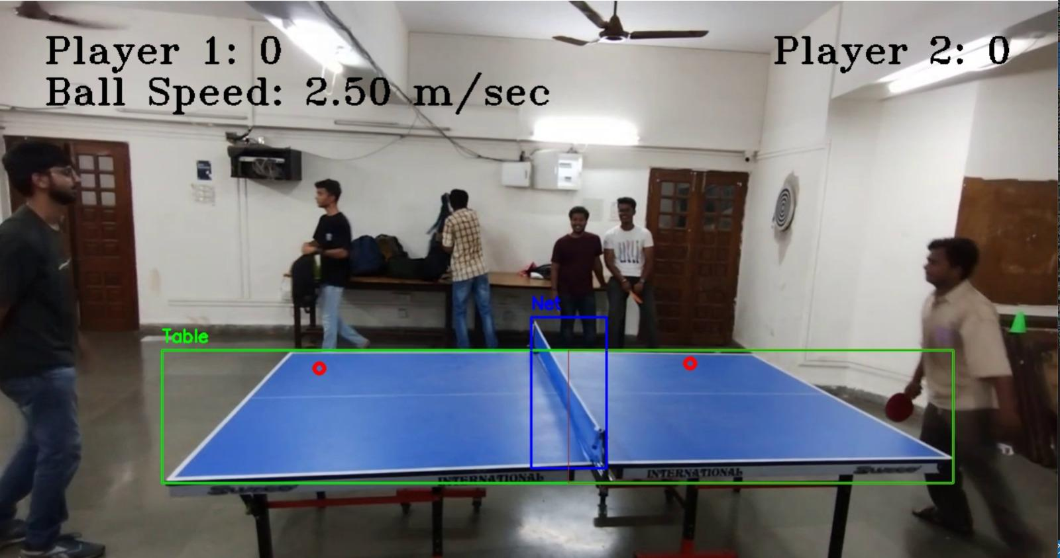

**Fig 7.4: Output of System**

## Performance Evaluation Measures:

**1. Precision:**  
Precision is one indicator of the ball tracking system’s performance — the quality of a ball detection made by the model. Precision refers to the number of true ball detections divided by the total number of positive detections (i.e., the number of true ball detections plus the number of false ball detections).  
The formula is:

where:  
 TP = True Positives (correct ball detections)  
 FP = False Positives (wrong detections like racket/hand wrongly detected as ball)

**2. Recall:**

Recall is calculated as the ratio between the number of actual balls correctly detected and the total number of balls present. The recall measures the system's ability to detect the ball accurately in all frames.  
 The formula is:



where:  
 TP = True Positives (correct ball detections)  
 FN = False Negatives (missed ball detections)

**3. F1-Score:**  
The F1-Score (also called the F-measure) is a metric used to evaluate the overall performance of the ball detection system. It combines precision and recall into a single score to balance both false positives and false negatives.  
 The formula is:



## Input Parameters/Features considered:

* **Ball Position Coordinates (X, Y):** Captured from video frames using computer vision techniques to track the ball's real-time movement.
* **Ball Speed:** Calculated based on the change in ball position over time (distance/time) to determine ball velocity and detect fast rallies.
* **Player Paddle Position:** Tracked using template matching or keypoint detection to identify paddle-ball interactions and validate scoring events.  
  **Table Boundaries:** Defined to differentiate between valid in-bounds and out-of-bounds ball movements.
* **Bounce Detection:** Identifying when and where the ball hits the table surface to validate rally rules and scoring.
* **Frame Timestamp:** Used for synchronizing events like ball hits, paddle movements, and bounce timing to ensure accuracy.
* **Rally Detection Flags:** Logical features marking the start and end of rallies, based on ball speed drops, bounces, or misses.
* **Score Counter State:** Internal tracking of each player's points, updated in real-time based on the rally outcome.

## Comparison of Results with Existing System:

| **Other System** | **Our System** |
| --- | --- |
| Manual scoring by umpires, prone to human errors. | Automated scoring using AI, minimizing human error. |
| Speed estimation of the ball is generally not provided. | Ball speed is accurately estimated and displayed in real-time. |
| Only provides basic match recording without analytics. | Provides in-depth analytics like shot tracking, ball trajectory, and speed graphs. |
| Errors and point disputes are difficult to verify manually. | Video-based point verification and detailed event logs help resolve disputes. |

## Inference Drawn:

Existing table tennis analysis systems either depend heavily on manual observation or offer only basic video recording without intelligent insights. Our AI-Driven Table Tennis Analyzer overcomes these limitations by **automatically tracking the ball, calculating speed, scoring accurately, and providing data-rich feedback** to players and referees, thus enhancing transparency and performance evaluation.

# Chapter 8: Conclusion

## Limitations:

* + - Limited Ball Speed Handling: The system may not accurately track the ball at very high speeds due to hardware and frame rate constraints.
    - Lighting Conditions: Performance can degrade under poor or inconsistent lighting, leading to inaccurate detection.
    - Occlusion Issues: If the ball is hidden behind a player's hand or paddle, detection might temporarily fail.
    - Camera Quality Dependency: Accuracy is highly dependent on the resolution and frame rate of the camera used.
    - Table and Background Color Interference: Similar color tones between the ball and the background/table can affect ball visibility.
    - Fixed Setup Requirements: The system may require a fixed camera setup and calibration for each environment, limiting portability.

## Conclusion:

This project successfully demonstrates the potential of integrating advanced computer vision techniques to create an automated table tennis scoring and ball-tracking system. By leveraging methods such as template matching, edge detection, and background subtraction, the system achieves real-time ball tracking and accurate scoring, minimizing the risk of human error. This offers a significant improvement over traditional manual methods, ensuring a more reliable, consistent, and objective approach to scoring in fast-paced games.

Beyond real-time gameplay, the system also provides valuable insights into player performance by tracking ball speed and bounce patterns. This data can be highly beneficial for players and coaches to analyze gameplay, optimize training regimens, and enhance skill development. The project demonstrates how AI and computer vision can elevate the precision and fairness of sports analytics, making it relevant not only for competitive matches but also for training environments. Overall, this innovation sets the stage for future applications of AI in sports, improving both the playing and viewing experience.

## Future Scope:

1. High-Speed Ball Tracking: By integrating higher frame-rate cameras and optimizing algorithms, the system can be made capable of accurately tracking faster ball movements, making it suitable for professional matches.
2. 3D Motion Analysis: Using stereo cameras or depth sensors, future versions can capture the 3D trajectory of the ball to provide more precise bounce and spin analysis.
3. Player Performance Analytics: The system can be extended to track player movements and strokes, offering insights into reaction times, shot accuracy, and overall performance – useful for training and coaching.
4. AI-Based Decision Support: Integration of deep learning models could help the system in making real-time decisions such as fault detection, net touches, or illegal serves, aiding referees during live matches.
5. Mobile and Web Integration: A connected platform could be developed to allow users to view scores, match highlights, and analytics via mobile or web applications.

# References

1. Ericsson, A.; Prietula, M.; Cokely, E. The Making of an Expert Harvard Business Review (July–August 2007). Expert Harv. Bus. Rev. 2007, 85, 114. https://www.scirp.org/reference/referencespapers?referenceid=2977088
2. W. Li, X. Tan and Z. Wang, "Small Object Detection of Table Tennis Based on Deep Learning Network," 2020 International Conference on Computer Science and Management Technology (ICCSMT), Shanghai, China https://ieeexplore.ieee.org/document/9443773
3. H. Myint, P. Wong, L. Dooley and A. Hopgood, "Tracking a table tennis ball for umpiring purposes," 2015 14th IAPR International Conference on Machine Vision Applications (MVA), Tokyo, Japan, 2015 https://ieeexplore.ieee.org/document/7153160
4. R. Voeikov, N. Falaleev and R. Baikulov, "TTNet: Real-time temporal and spatial video analysis of table tennis," 2020 IEEE/CVF Conference on Computer Vision and Pattern Recognition Workshops (CVPRW), Seattle, WA, USA, 2020 https://ieeexplore.ieee.org/abstract/document/9150877

1. **Project review sheet**

**Project review sheet1:  
  
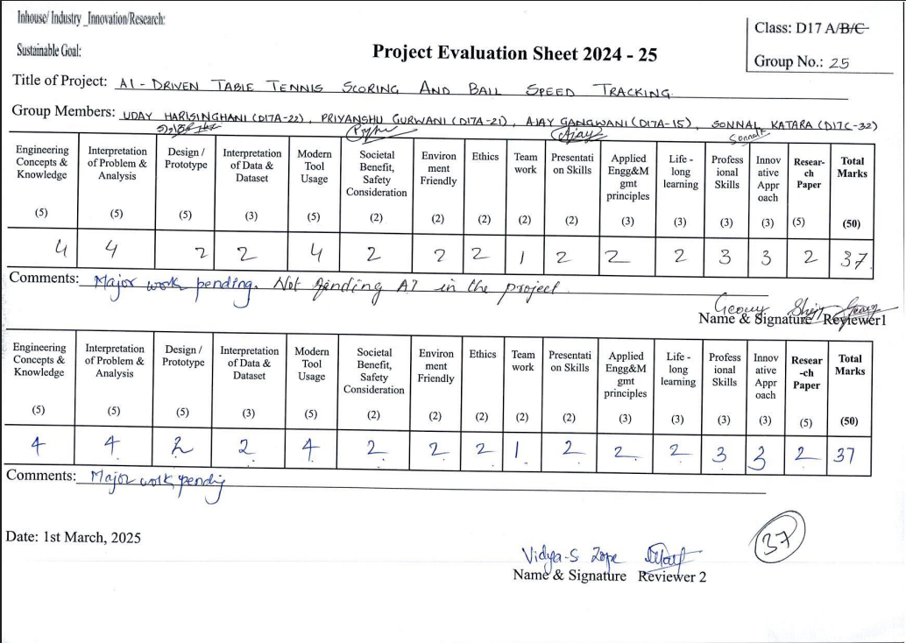**

**Project review sheet 2**

